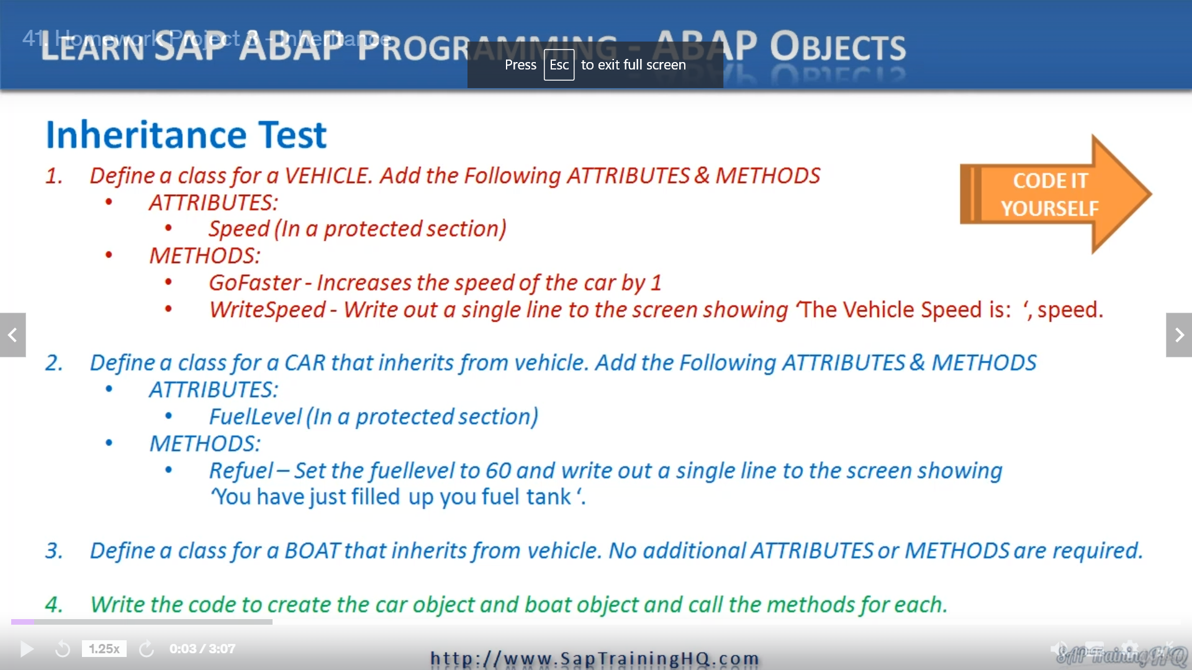

In this lesson, we're going to start writing about code that creates subclasses.

But I want you to do it, not me.

OK, so you've seen actually the basic syntax is really not much to it.

If I skew back a little bit here, you can see the class or the subclass definition.

So all we do is say class, give it a name and then we specify definition inheriting from and then specify

the superclass.

So that's the definition area.

When we come to the implementation side, you code things exactly the same as a normal class.

So if you need to define a method, you just say method and then your method name.

Simple is that if we're inheriting methods from our superclass and we don't need to change anything,

you don't have to write anything.

Our subclass will automatically inherit the methods and attributes of its superclass.

So it's really simple, so back to this test, what I want you to do, first of all, is create a vehicle

costs and I want you to add some attributes and methods for the attributes, simple speed.

And I want you to make sure this goes in the protected section then for the methods, just great to

methods go faster, which will increase the speed of a car by one and then right speed, which will

write out a single line to the screen showing the vehicle speed is and then put the speed.

For the next part, this is where the inheritance comes in.

I want you to define a subclass for car that inherits from vehicle, and I want you to add a brand new

attribute to the subclass and a brand new method.

The attribute is going to be fuel level.

And again, this is in the protected section.

And then for the method, it's going to be refuel.

And I want you to set the fuel level to the value of 60 and write out a single line to the screen showing

you have just filled up your fuel tank.

Then I want you to create another subclass called Boat that's inherited from vehicle again, but this

one has no additional attributes or methods.

So we to see if you can work out the code needed for this, once the classes have been defined, then

just a little bit of code that will create the count object and both object and call the methods for

each one.

Now it's open to your interpretation exactly how you want to do it, but this is just to get you to

become familiar with the syntax for creating subclasses that inherit from the parent class.

Once you've done it, move on to the next video and you'll see me create a solution.

And whilst I'm doing it, you can compare it to what you've done.